**Part- 1: SQL Assignment**

* Please install SQL Server developer version in your environment if it is already not there.

I already have SQL Server 2022 Developer Edition

* Create necessary tables and insert required data as per the assignments.

1. Consider the following **ProductSales** table

|  |  |  |
| --- | --- | --- |
| Product | Customer | Sales |
| A | C1 | 1200 |
| B | C1 | 250 |
| A | C2 | 110 |
| C | C3 | 450 |
| B | C3 | 1000 |

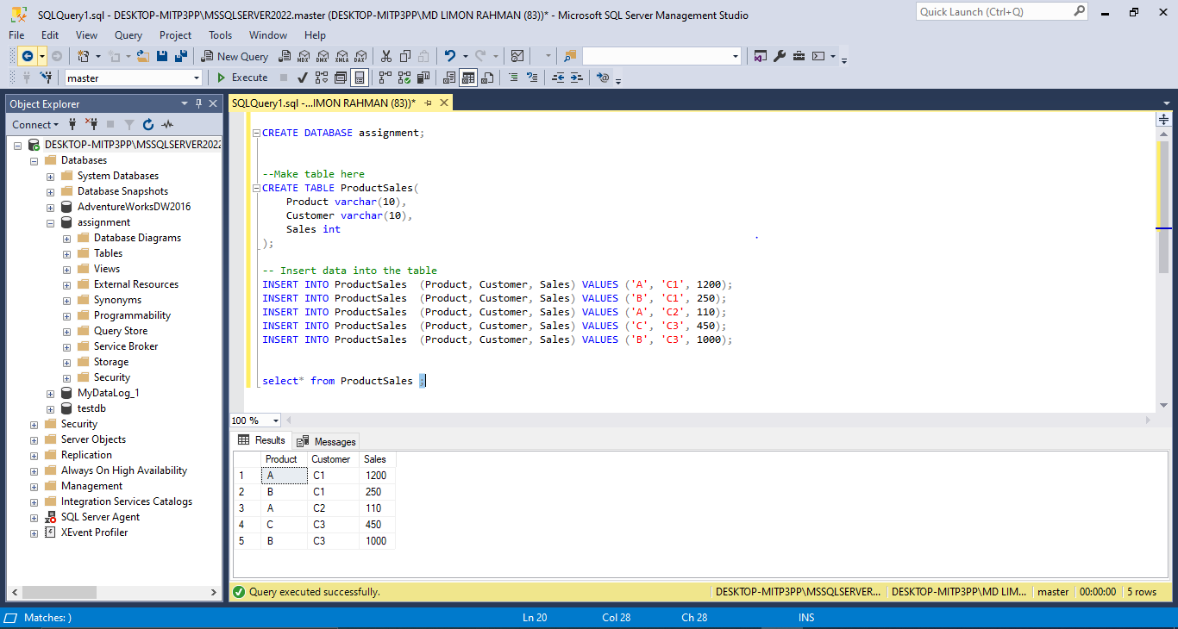

Write a query to find the product which has the highest sales.

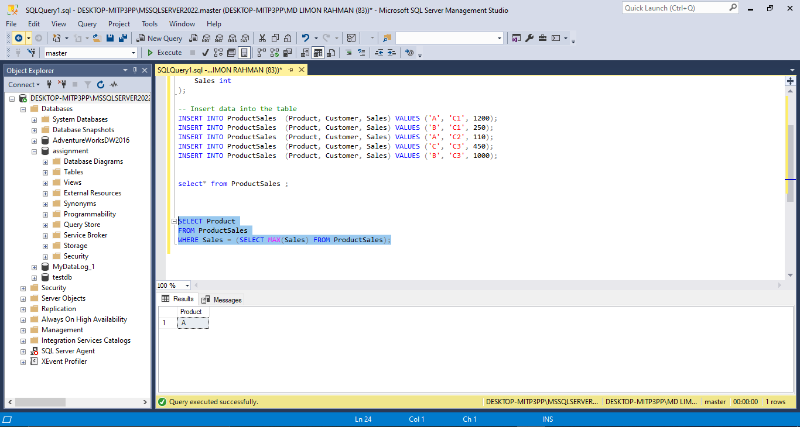

1. You have two tables:

Table: **Student** Table: **Mark**

|  |  |
| --- | --- |
| **Roll** | **Name** |
| 1 | A |
| 2 | B |
| 3 | C |

|  |  |
| --- | --- |
| **Roll** | **Mark** |
| 1 | 85 |
| 3 | 95 |

Write a query which gives the following output:

|  |  |  |
| --- | --- | --- |
| **Roll** | **Name** | **Mark** |
| 3 | C | 95 |
| 1 | A | 85 |
| 2 | B | 0 |

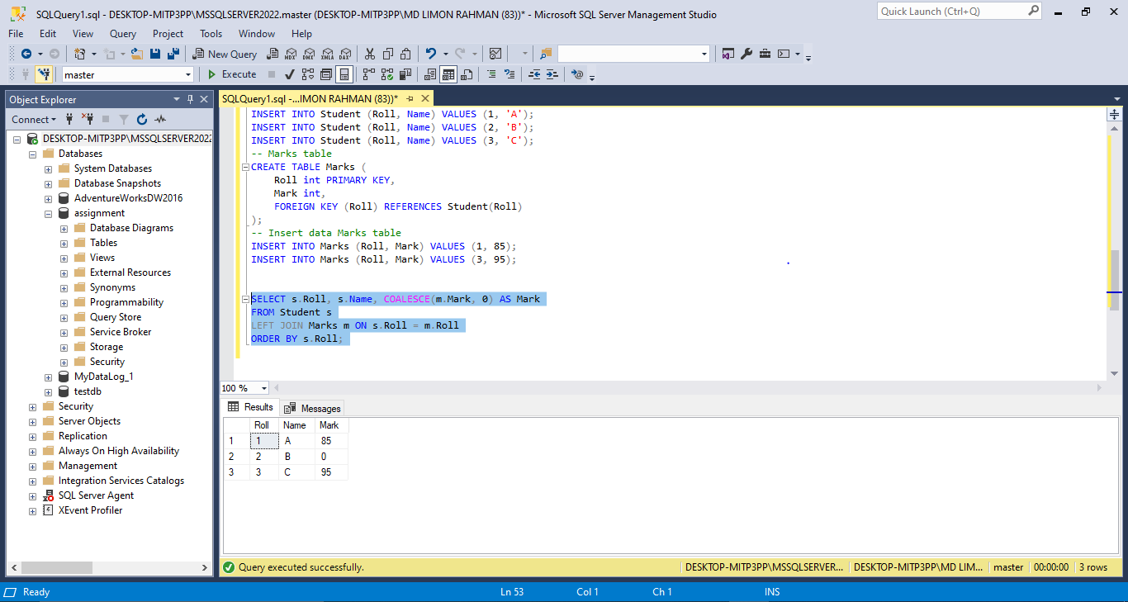

1. Consider the situation of question (2). This time write a query which gives a output like below: -

|  |  |  |  |
| --- | --- | --- | --- |
| **Roll** | **Name** | **Mark** | **Position** |
| 1 | A | 85 | 2 |
| 2 | B | 0 | 3 |
| 3 | C | 95 | 1 |

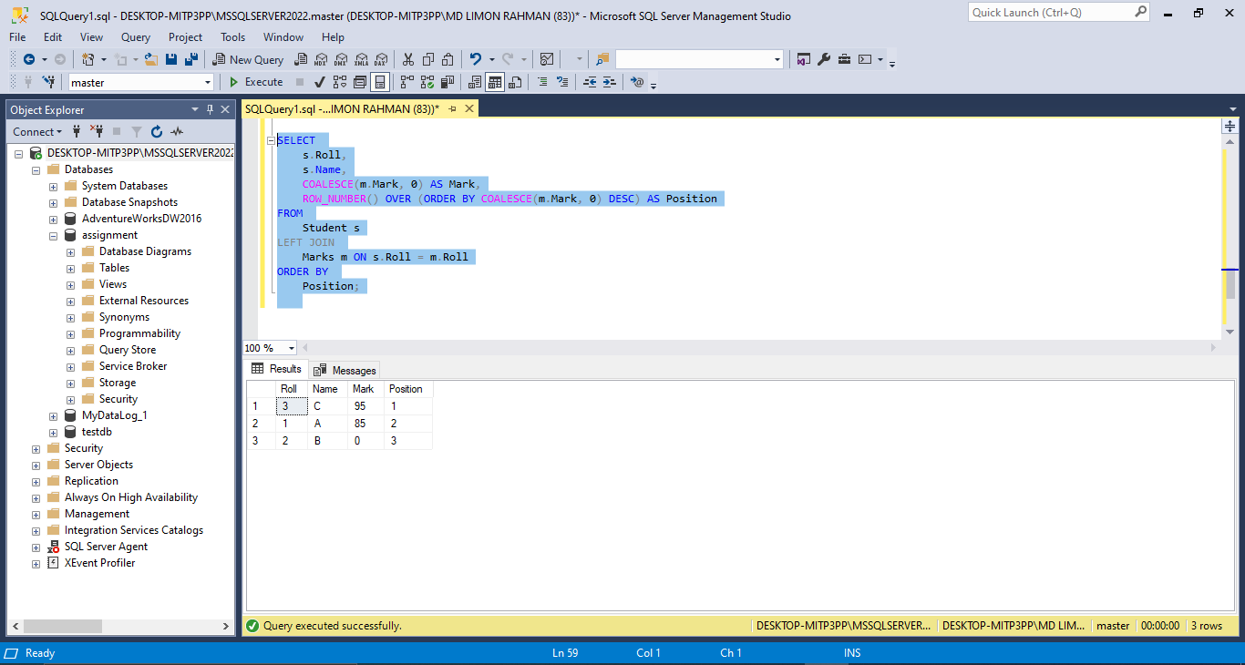

1. Consider the situation of question (2) again. Now you have to write a query which gives the following result -

|  |  |  |
| --- | --- | --- |
| Roll | Name | Grade |
| 1 | A | A |
| 2 | B | F |
| 3 | C | A+ |

Mark and Grade mapping is as follows:

0 to 79 is F

80 to 89 is A

90 and above is A+

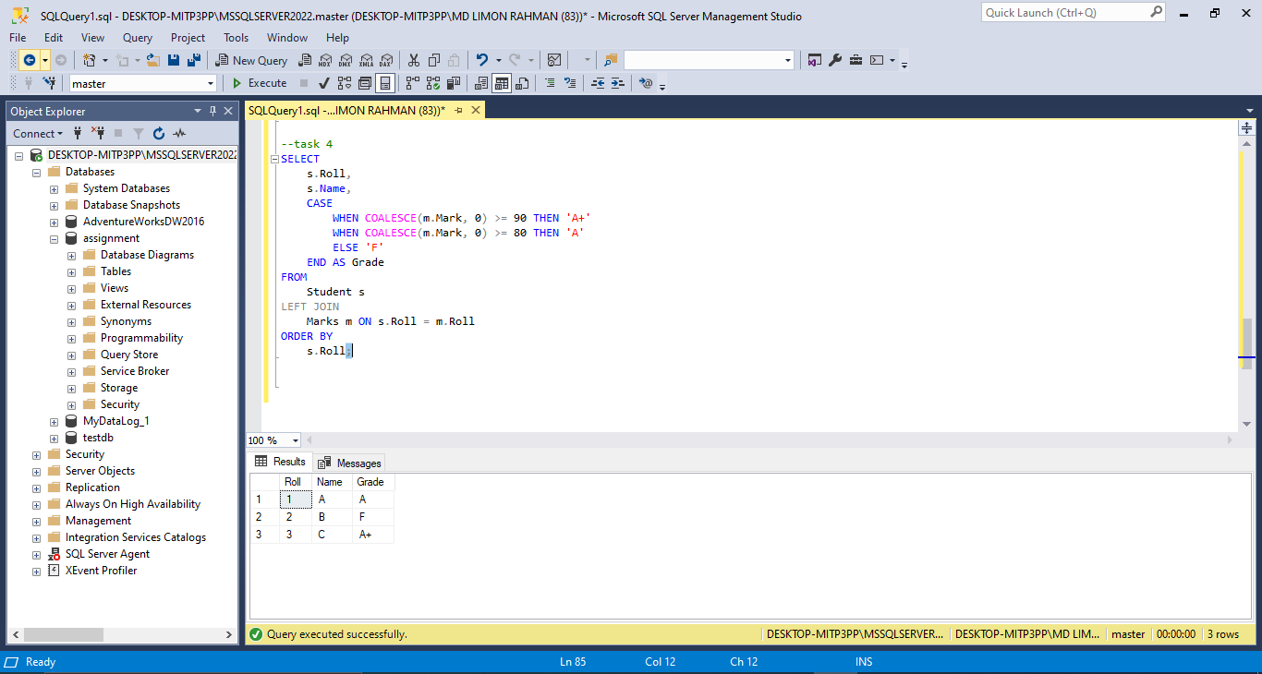

1. You have the following table Student -

|  |  |
| --- | --- |
| **Name** | **Roll** |
| Karim | 1 |
| Rahim | 2 |
| Karim | 3 |

Write a query to give the below result. You cannot use the SQL keyword **DISTINCT.**

|  |
| --- |
| **Unique Name** |
| Karim |
| Rahim |

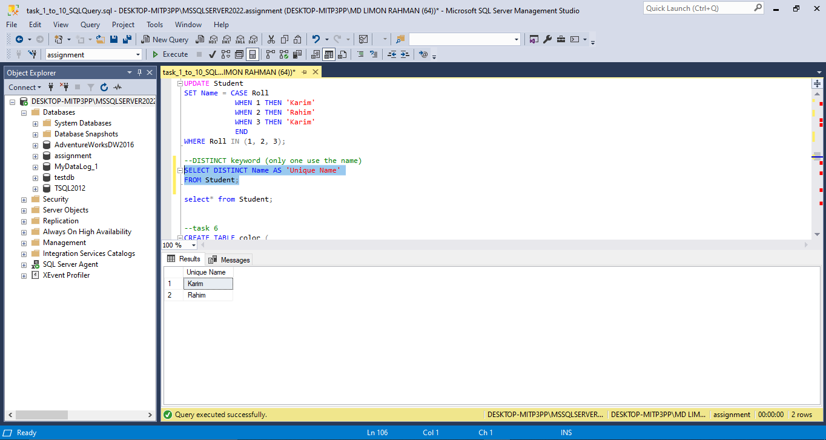

1. Suppose we have a table named Colors that has one column named “Name”. Sample data in this table is shown below.

|  |
| --- |
| **Name** |
| red |
| black |
| White |
| Green |
| Orange |

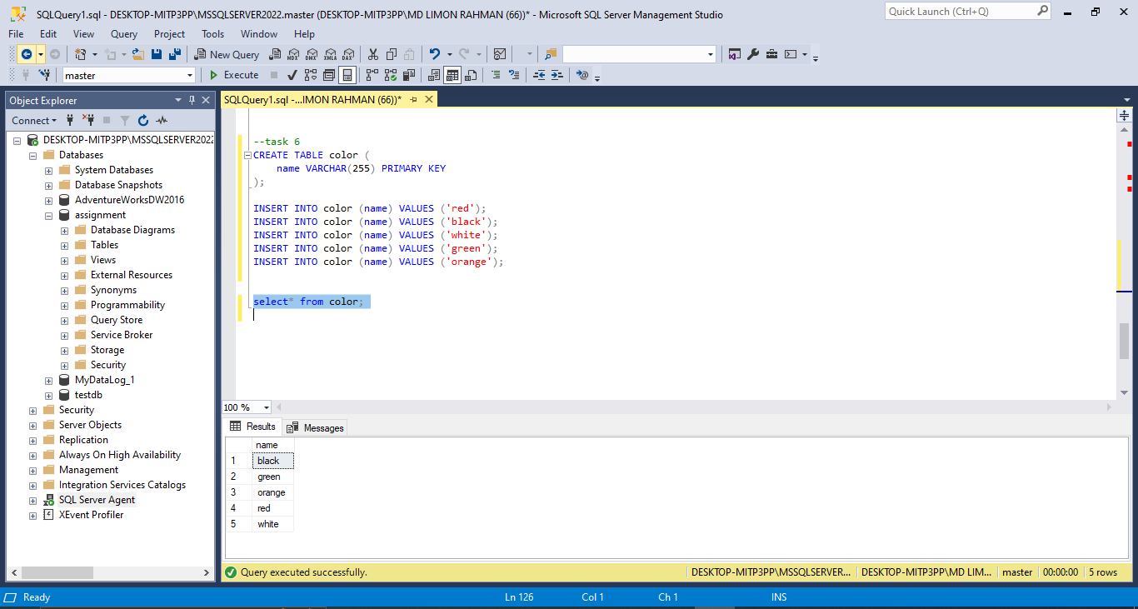

Write a SQL query that will select all pairs without allowing duplicates. Permutations are counted too ({red, black} = {black, red}, hence only one of the pair is allowed). A pair will not have same color.

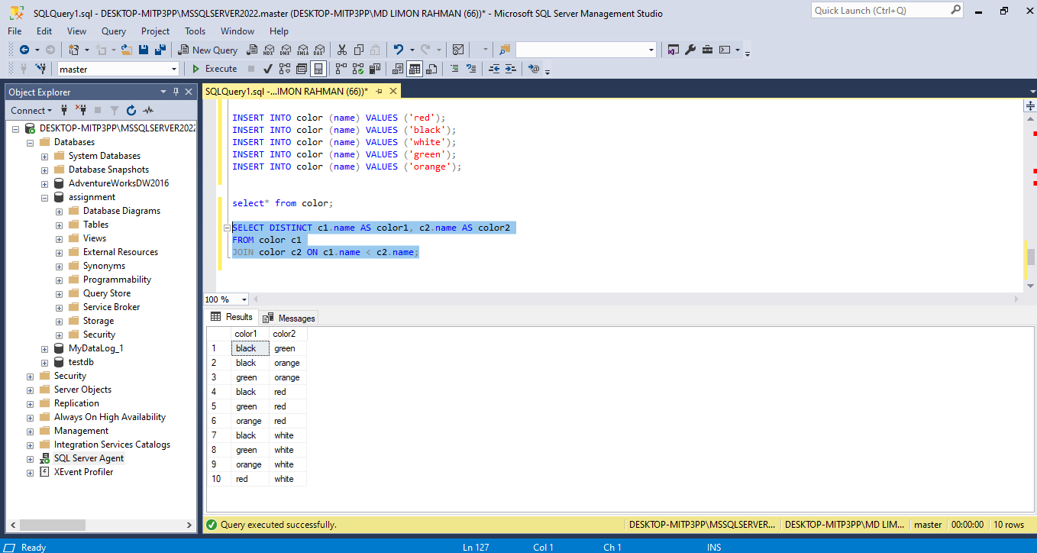

1. Suppose we have a table named TestValue.

|  |  |  |
| --- | --- | --- |
| **Value1** | **Value2** | **Value3** |
| **10** | **19** | **17** |
| **78** | **8** | **91** |

Write a query to find the maximum value ceiled to multiples of 10 among these three columns. For example, in the above table maximum value is 91 and your query should return 100.

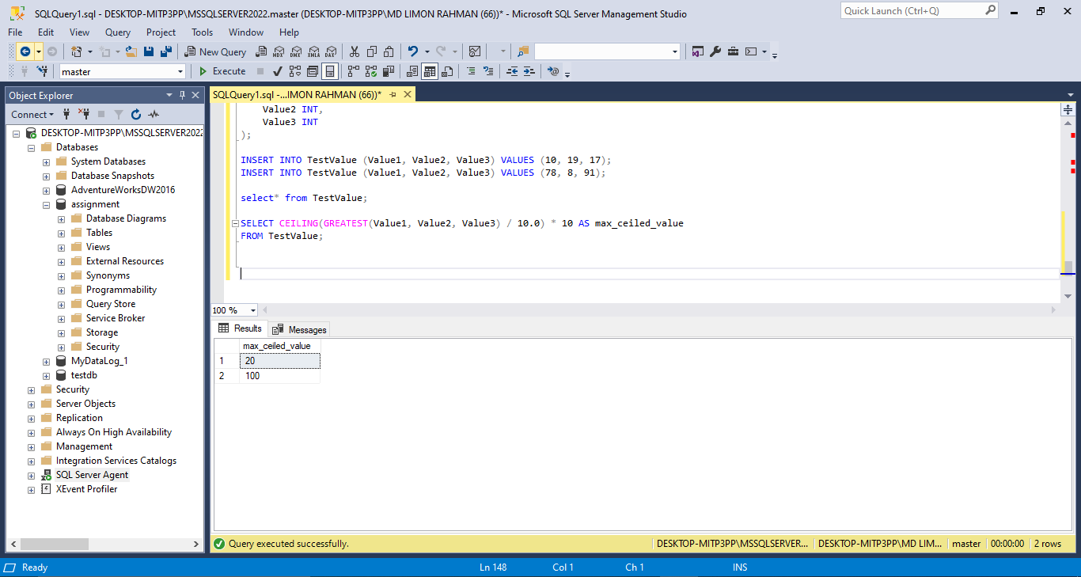

1. Write a program using SQL that prints the numbers from 1 to 100. But for multiples of three print “Fizz” instead of the number and for the multiples of five print “Buzz”. For numbers which are multiples of both three and five print “FizzBuzz”

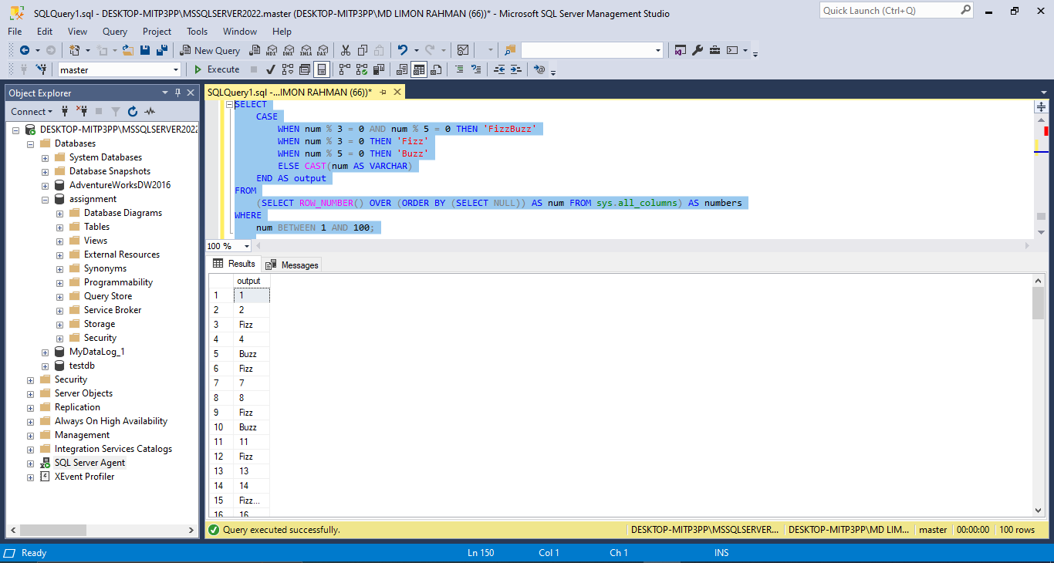

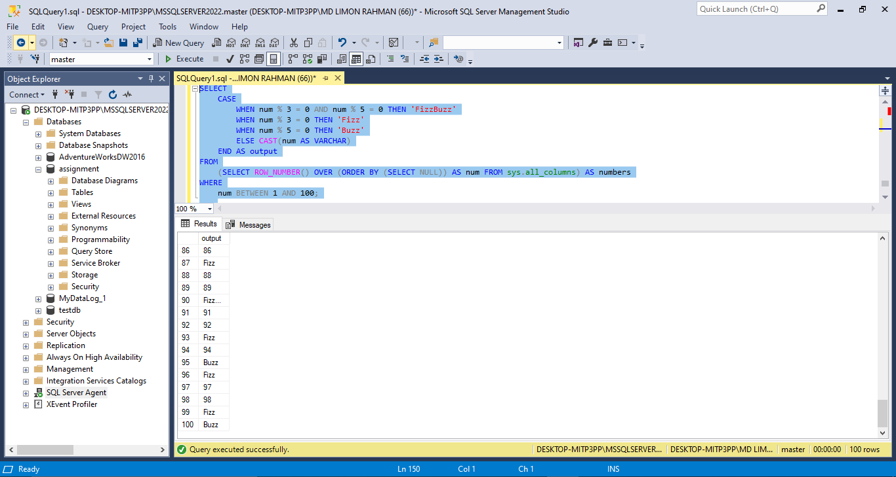

.

1. Suppose we have a table with one column named Numbers. Find the Closest number of a given number from the table. Following is a sample table.

|  |
| --- |
| Number |
| 2 |
| 4 |
| 98 |
| 34 |
| 55 |
| 23 |
| 45 |
| 65 |

For example: we need to find out the closest number of 27 which will be 23 in this sample table.

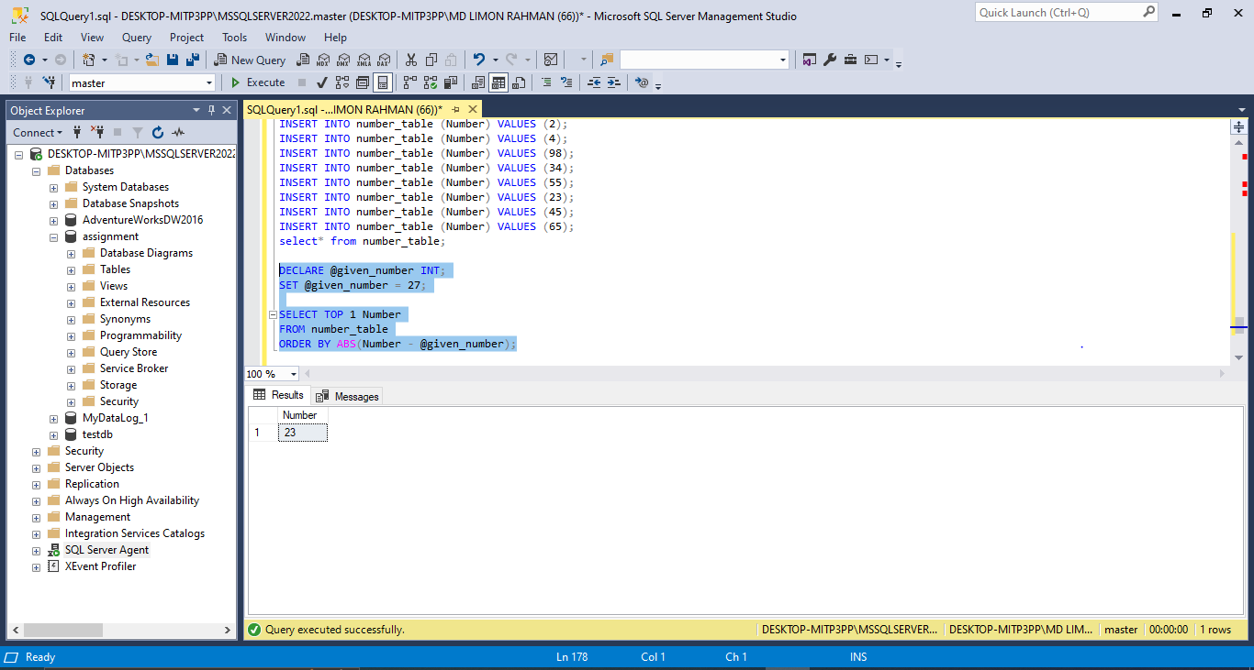

1. Write a function that takes a string and give a Boolean output that indicates whether the string is a palindrome or not. For example, madam is a palindrome and adam is not. So the function will return true for madam and false for adam.

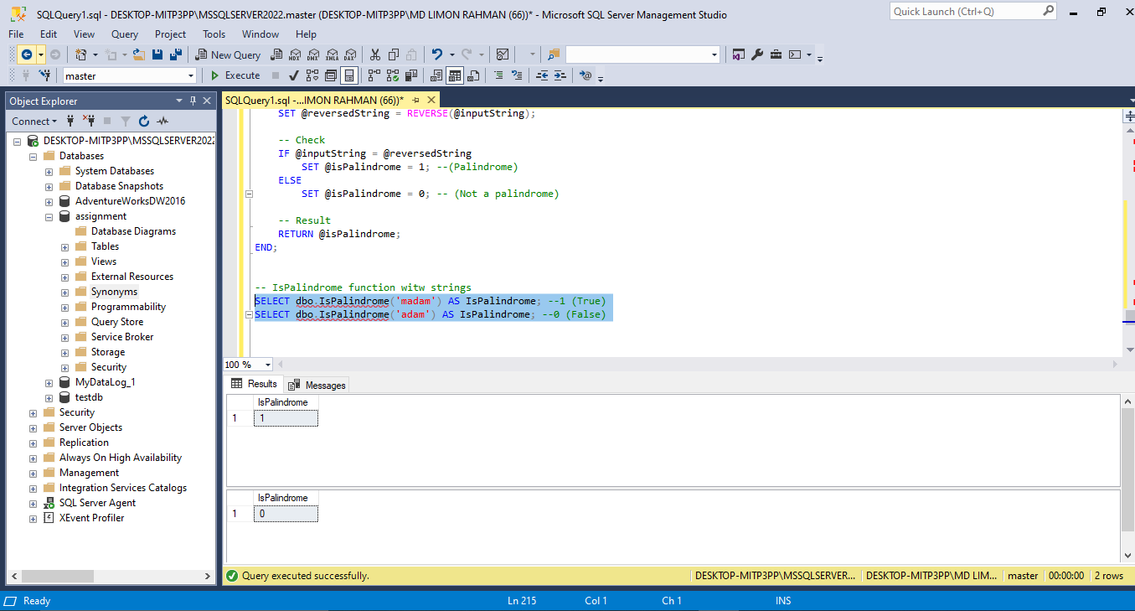

1. Write a function that takes 2 strings and given a Boolean output that indicates whether the both of them are anagram or not. Any word or phrase that exactly reproduces the letters in another order is an anagram. For example, ***army*** and ***mary*** are anagram

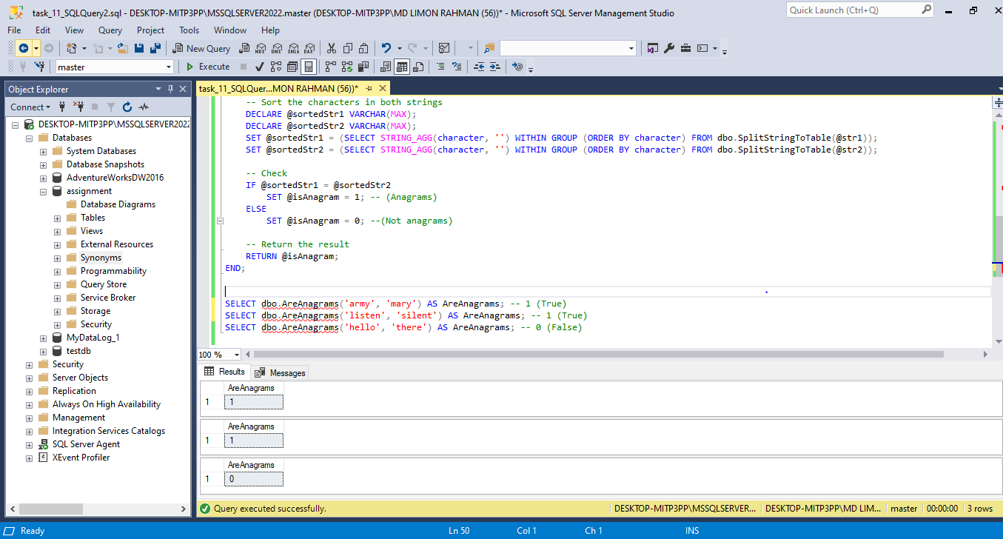

**Part-2: Design Assignment**

1. Consider a system where employee record is kept. The database should store employee name, department etc. Every employee has a reporting manager to whom he has to report. There are 4 levels of employee – 1. Junior Developer, 2. Senior Developer, 3. Team Leader, 4. Senior Team Leader. Every junior developer has to report to Senior Developer. Every senior Developer has to report to team leader. Every team leader has to report to senior team leader.

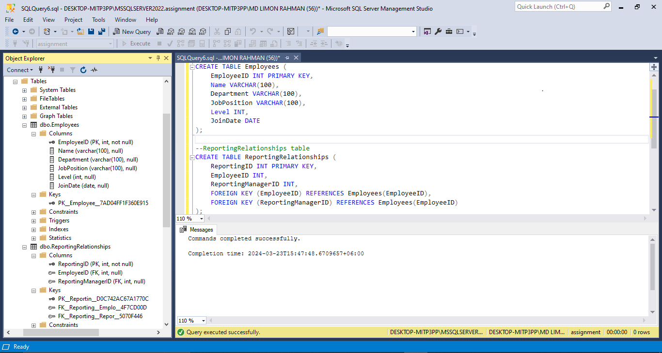

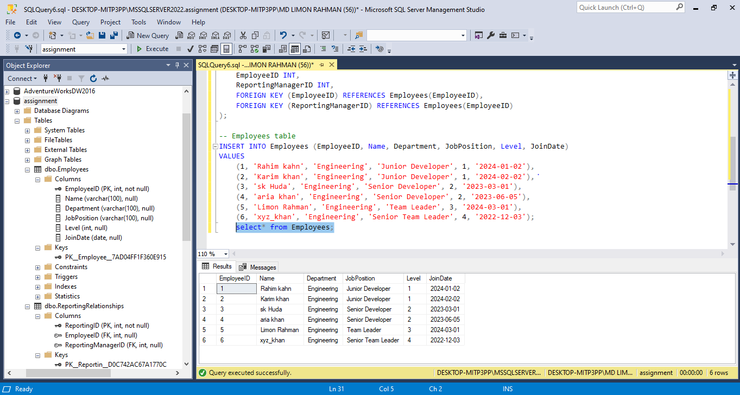

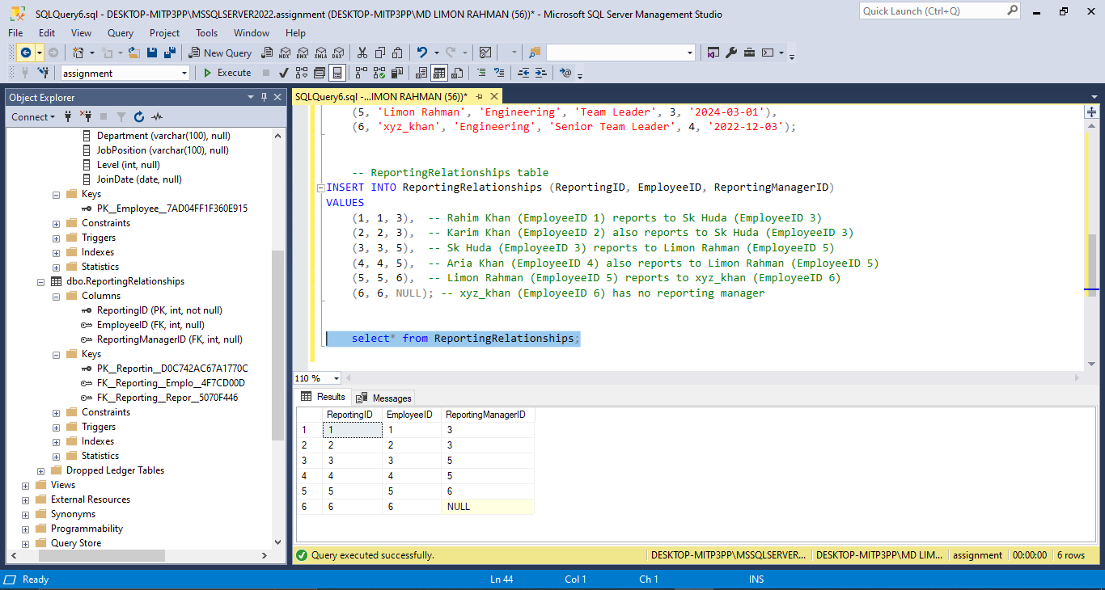

Design a database that can store this information. Draw the ERD in SQL Server using Database Diagrams.

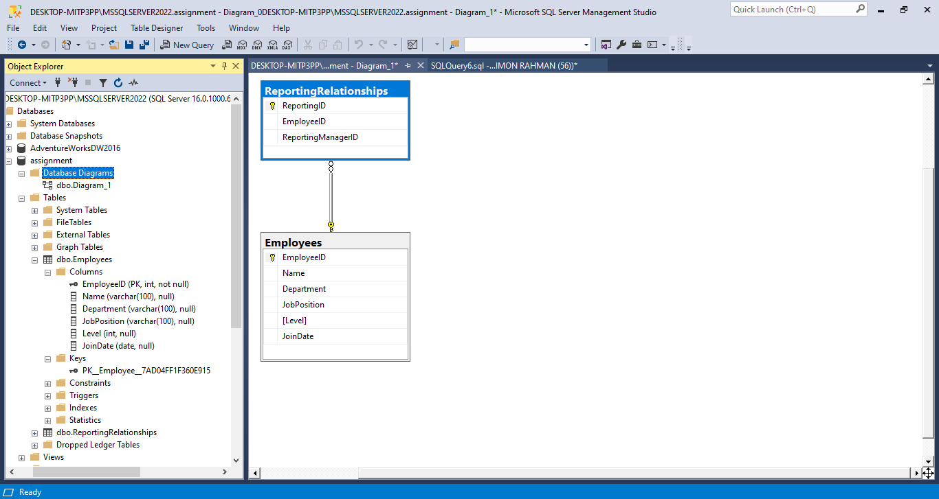

1. ICC Cricket World Cup 2023 is past. We want to build a database to record all the scores of every match. Design this database so that we can store data efficiently and also can easily find answer of the following statistical question.

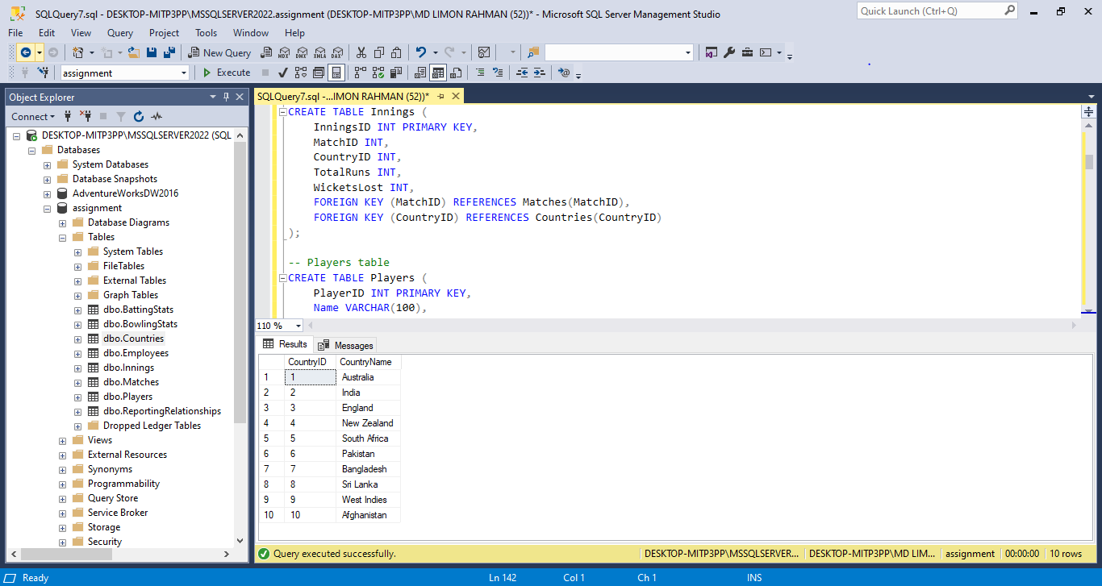

1. Which batsman has the most runs?

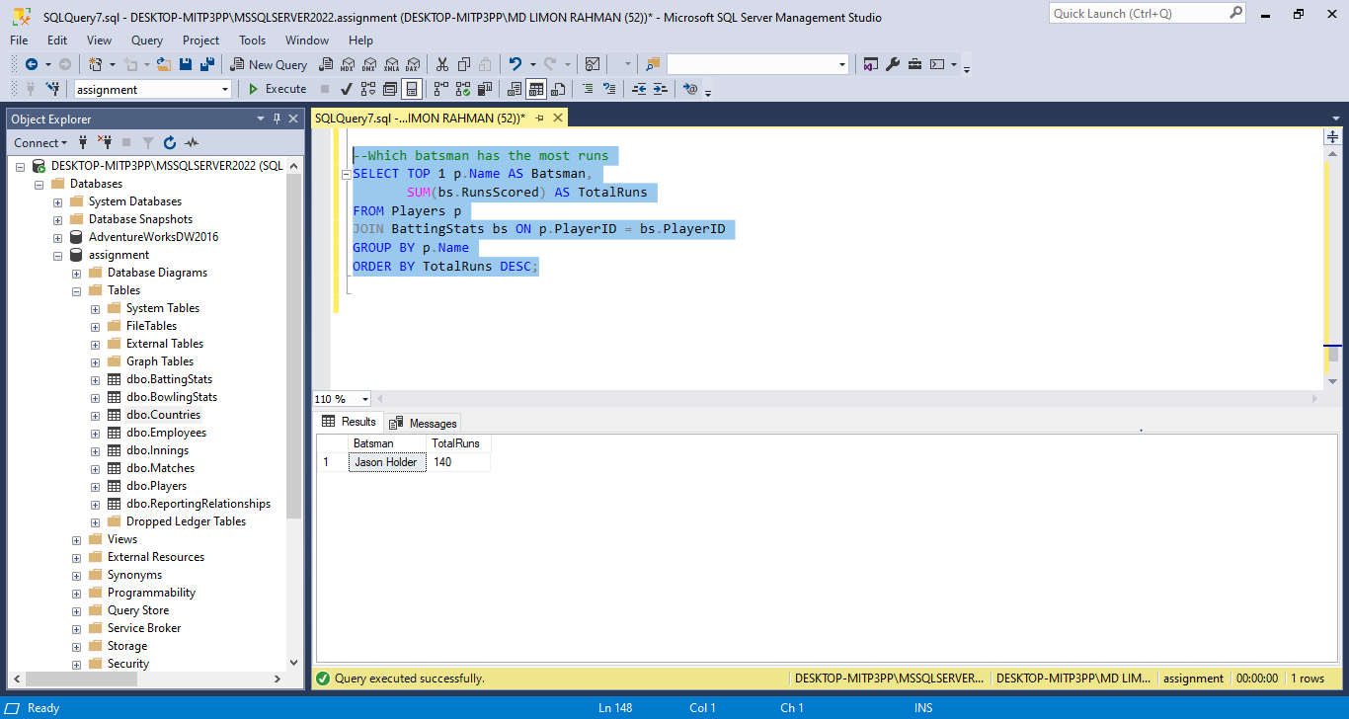

1. Which bowler has the most wickets?

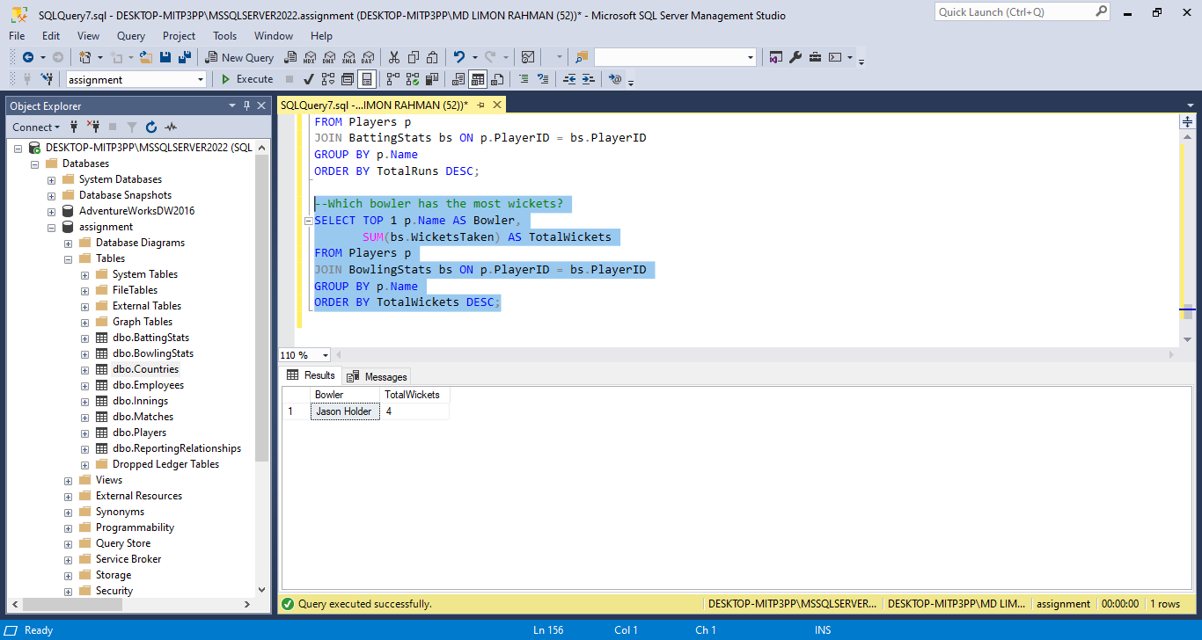

1. Which country has highest score in a single innings?

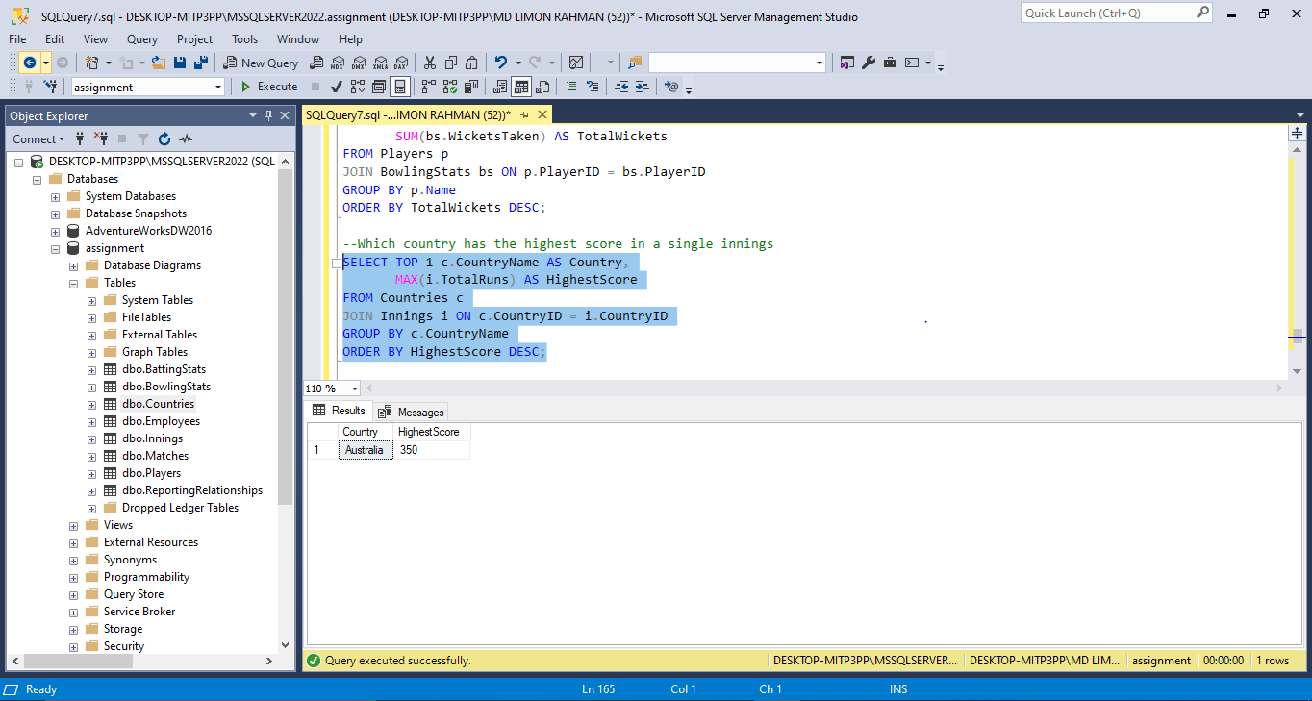

1. Which country has the lowest score in a single innings☹?

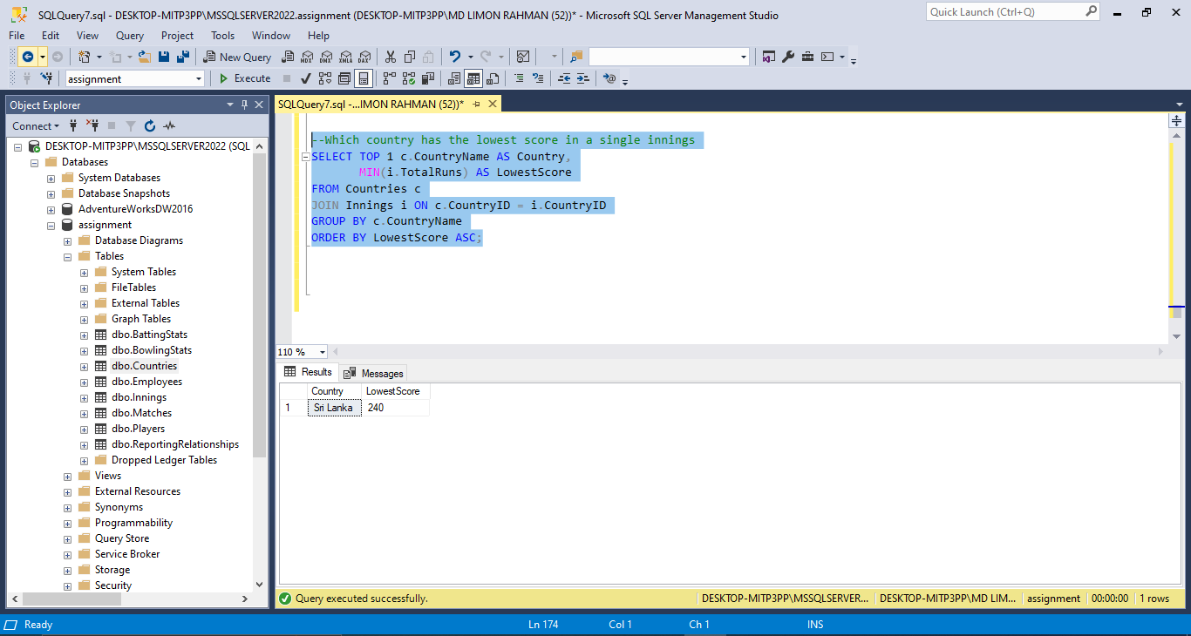

1. What is the highest score made by a batsman played at position 6?

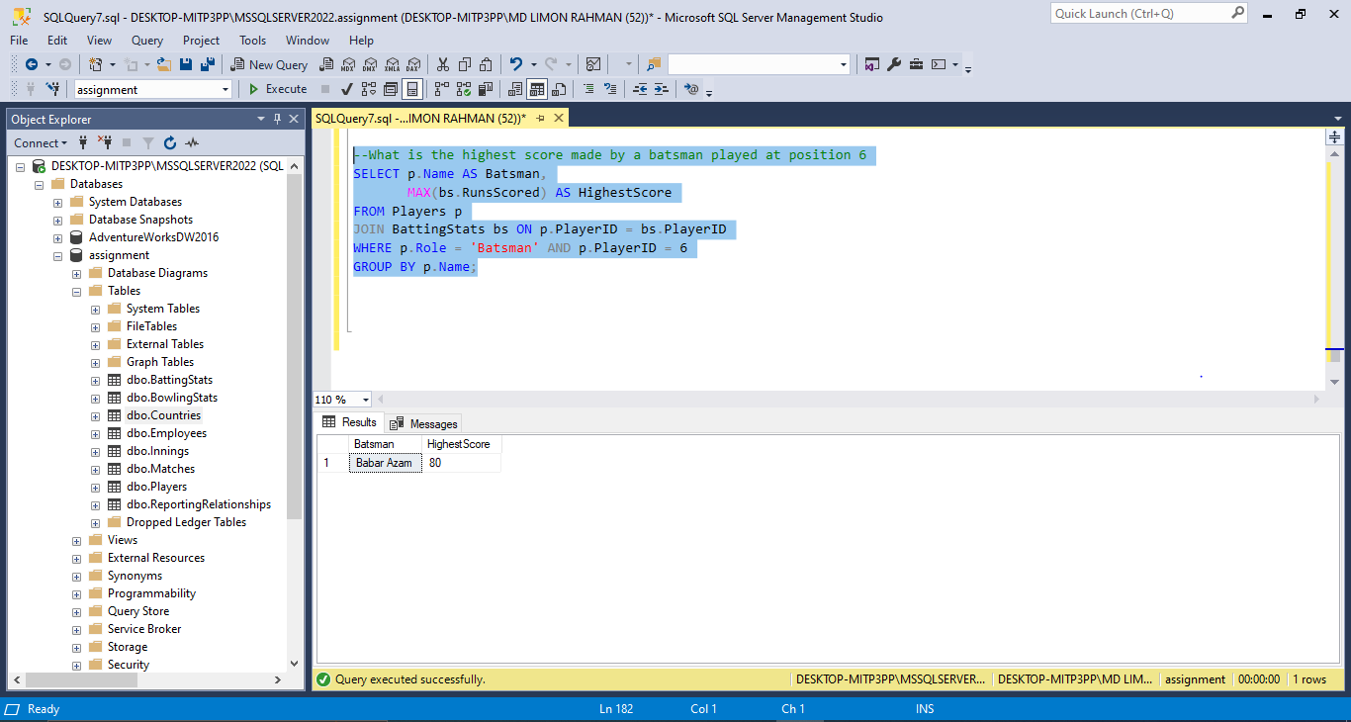

1. What is the average score of Bangladesh?

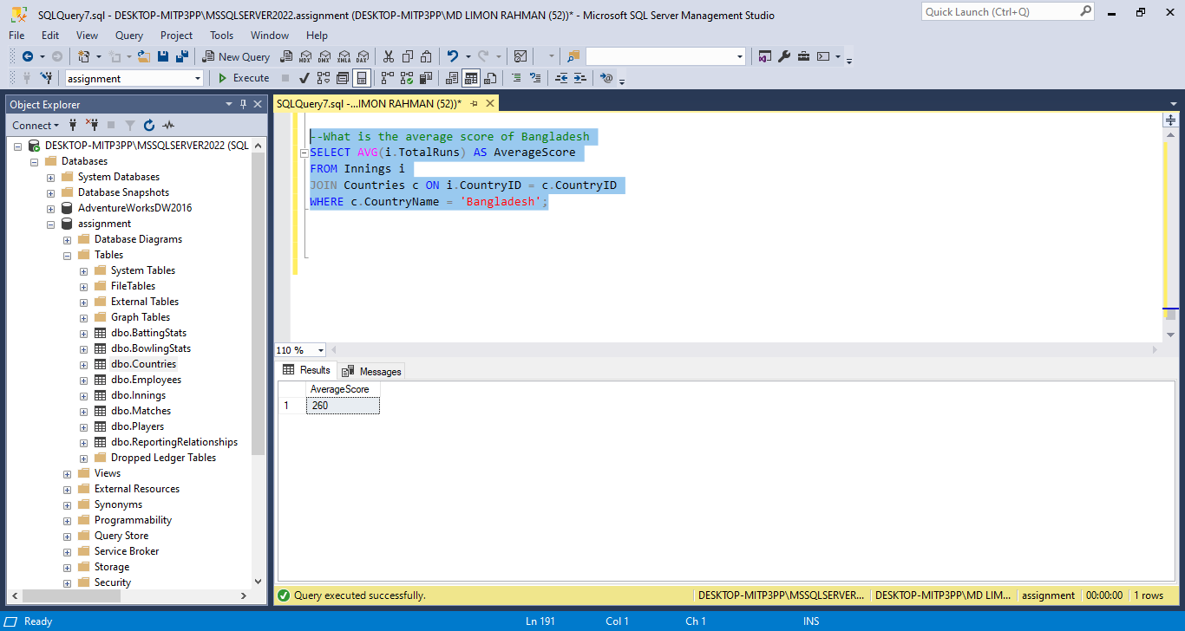

You can use Entity Relationship diagram to express your design. Then write sql queries to provide the above mentioned statistics.

